ACADEMIC MODEL PROVIDING ACCESS TO HEALTHCARE (AMPATH)

In 1989, Indiana University (IU) School of Medicine and Moi University in Eldoret, Kenya, established a partnership to promote collegial relationships between American and Kenyan medical doctors, scientists, and students; foster the values of the medical profession; and promote health and well-being in both Kenya and the US. The Moi University School of Medicine welcomed its first medical class of 40 students in 1990 alongside a full-time IU faculty physician based in Kenya, the first in a three-decade string of IU faculty physicians to work alongside Moi colleagues, care for Kenyan patients, conduct health research, and teach American and Kenyan medical students. By the mid-1990s, the success of the collaboration led other universities to join the partnership in Kenya and form what is now called the Academic Model Providing Access to Healthcare (AMPATH). The AMPATH Consortium currently consists of 13 academic health centers in the US, Canada and Europe led by IU in partnership with Moi University and Moi Teaching and Referral Hospital. During its first decade, the collaboration supported faculty development and medical education with at least one full-time IU School of Medicine faculty based in Eldoret and integrated into Moi University School of Medicine’s clinical departments, who provided education and clinical care on the wards of Moi Teaching and Referral Hospital. In addition, the collaboration established extensive opportunities for reciprocal medical exchange and training that allowed Moi University faculty, staff, and students to access training opportunities and medical rotations at IU School of Medicine. Faculty, staff, and trainees from IU School of Medicine also participated in training opportunities and medical rotations at Moi University School of Medicine in Kenya.
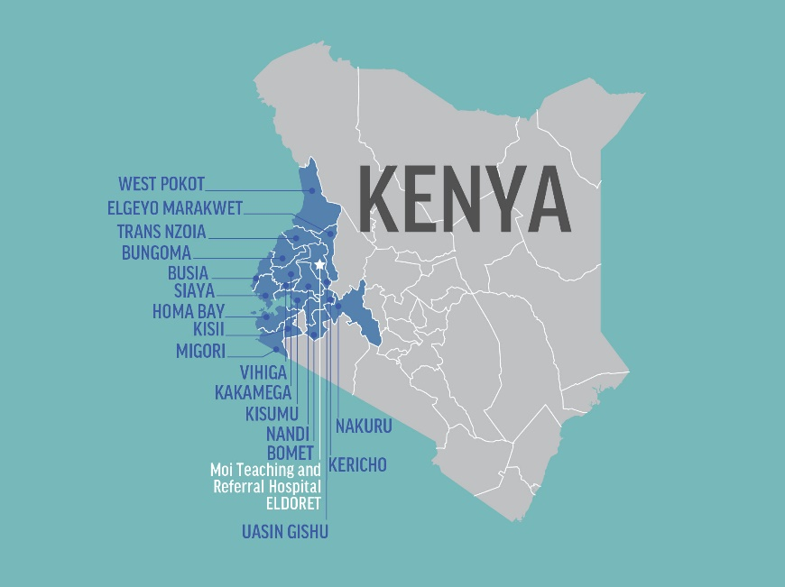
The collaboration evolved by the early 2000s to focus on the growing challenge of HIV in Kenya. In the early stages of Kenya’s HIV crisis, the incidence of mortality on hospital wards increased a thousand-fold and few treatment options were available. Partners from the IU School of Medicine raised private donations to fund the first 40 patients to receive antiretroviral therapy. AMPATH opened its first clinics in 2001 at Moi Teaching and Referral Hospital and Mosoriot. AMPATH received major grant funding in 2003 through the MTCT Plus Initiative, the first multi-country HIV treatment program, and from USAID-PEPFAR in 2004 (led by Columbia University) and 2007 (led by Indiana University) to expand HIV prevention and treatment services. Working in collaboration with the Kenya Ministry of Health, AMPATH became one of the largest HIV prevention and treatment programs in sub-Saharan Africa. USAID-PEPFAR awarded over $160 million from 2012 to 2021 through the AMPATHPlus project (led by Moi Teaching and Referral Hospital) to provide comprehensive HIV services in 10 counties across western Kenya. AMPATH is transforming its HIV care system into an integrated health care system inclusive of the treatment and control of HIV, but also addressing issues of maternal, newborn, and child health, as well as chronic diseases such as cancer, diabetes, cardiovascular disease and mental health. Currently, this AMPATH-Ministry of Health system serves a population of more than 8 million people in western Kenya, stretching from home and village to dispensaries, health centers, county hospitals, and the tertiary care center at Moi Teaching and Referral Hospital.
Catchment area for AMPATH activities in western Kenya
AMPATH is built on a tripartite mission of care, education, and research with a mission to improve the health of people in underserved communities by working in partnership with academic health centers, ministries of health and others to build public sector health systems and promote well-being. In this work, AMPATH is guided by the principle of “leading with care” and counterpart relationships based on mutual benefit, respect, and equity.

Kenyan Institutions Supporting AMPATH

Moi University College of Health Sciences
The Moi University College of Health Sciences is located on the Moi Teaching and Referral Hospital (MTRH) medical campus and encompasses four allied Schools in Medicine, Nursing, Public Health, and Dentistry as well as the Institute of Biomedical Informatics.
Moi University School of Medicine (MUSM) is Kenya’s second largest medical school. Founded in 1988, MUSM admitted its first class of students in 1990. Located near the grounds of the Moi Teaching and Referral Hospital outpatient complex, MUSM offers undergraduate courses in medicine and surgery, medical laboratory sciences, medical psychology and physical therapy and postgraduate courses in internal medicine, general surgery, orthopedic surgery, pediatrics and child health, radiology and imaging, reproductive health, psychiatry, international health research ethics, immunology, medical biochemistry, anesthesia and critical care, clinical pharmacy, medical informatics, medical education and clinical fellowship in gynecologic oncology. Currently, there are 907 undergraduate students and 361 postgraduate students.
Moi University School of Nursing (MUSN) was established in 1998 as a department in the MUSM with an initial class of 20 students. As the program grew it separated from MUSM in 2011 as founded as its own school. MUSN is organized into three departments: community health, nursing administration, and education; midwifery and gender; and child, adult, and mental health nursing. Since its inception, MUSN has graduated more than 500 baccalaureate nurses and 267 undergraduate students currently enrolled. MUSN also offers a postgraduate course in maternal and neonatal nursing and has graduated more than 60 students from its postgraduate program.
Moi University School of Public Health (MUSPH) was established as the Institute of Public Health in 1998 and founded as the MUSPH in 2004. MUSPH offers a Bachelor of Science degree in environmental health, Master of Public Health, and Master of Science in field epidemiology. The Master of Public Health program has five tracks: epidemiology and disease control, nutrition, health services management, health promotion, and disaster management. In collaboration with the AMREF International Training Centre, the MUSPH offers its Master of Public Health program at its Eldoret (main) and Nairobi (satellite) campus. MUSPH utilizes a Problem Based Learning and Community Based Education and Service learning approach. The school hosts 116 undergraduate students and 67 postgraduate students.
Moi University School of Dentistry was founded in 1996 and offers a bachelor’s degree in dental surgery with concentrations in seven areas: conservative dentistry and prosthetics; oral and maxillofacial surgery; oral medicine/oral pathology and radiology; community preventive dentistry; periodontology, pediatric dentistry and orthodontics; oral biology/anatomy/physiology and biochemistry; and dental clinical services. The school hosts 453 undergraduate students and 24 postgraduate students.
Moi University Institute of Biomedical Informatics (IBMI) was established in 2015 and seeks to apply information technology to improve healthcare in resource-limited countries. Its mission is to empower communities, individuals, providers and healthcare organizations to use information to improve health outcomes for all. IBMI supports short courses in health informatics management, system development, electronic health records, concept dictionary management, forms design, and system implementation, as well as masters and PhD level degrees in health informatics.

Moi Teaching and Referral Hospital
Established in 1916 as a small 60-bed clinic, Moi Teaching and Referral Hospital (MTRH) in Eldoret was designated as Kenya’s second national referral hospital in 1998 (Legal Notice No. 98 of 12th June 1998 of the State Corporations Act (Cap 446)). Today, MTRH is a level six hospital offering outpatient, inpatient and specialized healthcare services. It is the second largest national referral hospital in the country serving a patient population of approximately 24 million people throughout western Kenya, parts of eastern Uganda, and Southern Sudan. MTRH provides specialty care in oncology, renal medicine, pediatrics, pediatric surgery, kidney transplant, alcohol and drug addiction, spinal and neurosurgical operations, orthopedics and trauma, cardiology, maternal health, and a full range of other specialty health services. The hospital has an inpatient capacity of 960 beds, casualty department, and a wide array of outpatient specialty clinics. MTRH provides care to more than 400,000 inpatients and outpatients annually and serves as the major teaching facility for Moi University Schools of Medicine, Nursing, and Dentistry.
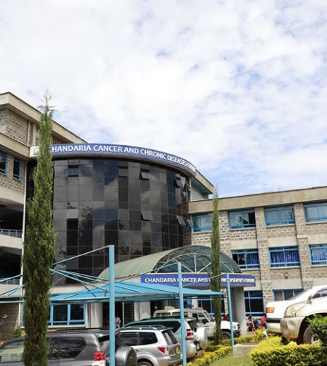
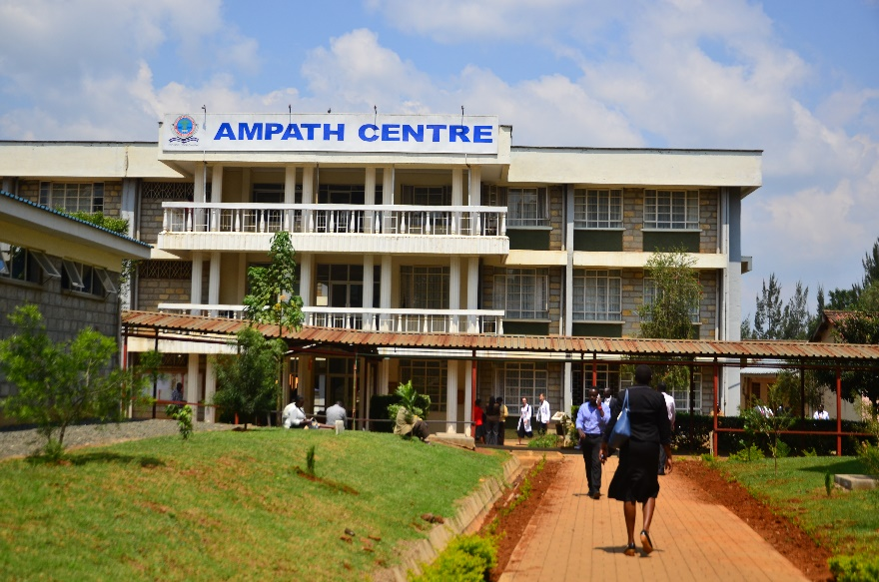
AMPATH Centre was built in 2005 on the grounds of Moi Teaching and Referral Hospital. The AMPATH Centre houses outpatient clinical, research, education including the AMPATH Training Institute, integrated communication and technology, and administrative activities within its multi-floor structure. Research office space is located with the AMPATH Centre, with a half floor dedicated to research and laboratory space. Additional space is allocated on a rental basis. The Center of Excellence for Cardiovascular and Pulmonary Disease Research has administrative offices in the AMPATH building. Large and small room conference space, with internet access for teleconferencing options, is available. Office space is available within AMPATH in close proximity to other researchers and faculty, which will facilitate access to research mentors, teachers, and to seminar space.
AMPATH Centre, Eldoret, Kenya

Riley Mother and Baby Hospital was built in 2009 on the MTRH campus as a dedicated mother-baby hospital and averages 40 deliveries per day (or about 14,000 deliveries per year). The neonatal intensive care unit has a capacity of 60 infants and averages 120 patients each day, with ventilator care and surfactant administration available. On average, 40% of babies need specialized care are referred from other hospitals or birthing centers across western Kenya.
Chandaria Cancer and Chronic Disease Center was built in 2015 on the MTRH campus. It provides outpatient clinical facilities for cancer, diabetes, cardiovascular disease, hypertension, and other chronic diseases. The building also has dedicated space for research activities, including a clinical trials unit, telemedicine and conferencing facilities, training and meeting space, office space for research studies, the AMPATH Biobank, and administrative support services.
Chandaria Cancer and Chronic
Disease Center, Eldoret, Kenya

Infrastructure Supporting Research

AMPATH Research Program Structure
The AMPATH Research Program was established in 1998 with a single collaborative research project and has grown to include more than 70 active studies involving collaborators from 20 institutions in North America, Europe, and Africa. Since 1998, AMPATH affiliated investigators have received more than $187 million in grants (with the majority coming from the US National Institutes of Health) and produced more than 1,000 publications in peer-reviewed journals. The AMPATH Research Program is supported by a robust research infrastructure including: an 8,500 square foot facility complete with office space available for rent to sponsored studies; an ISO-accredited laboratory, including biobanking and biospecimen storage capacity; an IRB with US Federal Wide Assurance; a research and sponsored projects office to assist in the responsible management of sponsor funds; research program office to coordinate research activities and program policies and procedures; research working groups that form a system of peer review of research proposals and provide mentorship to new investigators; and research cores that provide expertise in biostatistics and data management, informatics, and qualitative research. The AMPATH Research Program is co-led by a Kenyan faculty based at Moi University and a North American faculty based at the IU Center for Global Health, who are supported by 3 faculty field co-directors of research. An AMPATH Research Executive Committee made up of faculty leadership from AMPATH Consortium institutions meets monthly and provides leadership and governance oversight of research activities.

Research and Sponsored Projects Office
AMPATH’s Research and Sponsored Projects Office (RSPO) is the primary administrative support unit for sponsored projects and activities conducted at Moi University College of Health Sciences and Moi Teaching and Referral Hospital. Sponsored activities span AMPATH’s care, training and research missions from nearly 80 different sponsors including the NIH, USAID, the World Bank, and a variety of other foundations and philanthropic donors. At any given time, RSPO supports a portfolio of more than 140 sponsored awards for research totaling over $30 million USD in addition to nearly $13 million USD awarded by USAID for the AMPATH Plus HIV program each year, which is administered through a separate specialized unit at RSPO. RSPO houses 80 professional staff in five departments: grants and contracts (pre- and post- award support), human resources, compliance, procurement, and finance. Each sponsored project has program managers and/or research coordinators assigned to assist RSPO and provide fiscal management and oversight for specific programs and ensure compliance with all applicable government and sponsor regulations. RSPO has standard operating procedures for managing direct and indirect costs for contracts and subcontracts to ensure compliance with all applicable audit requirements under the Uniform Administrative Requirements, Cost Principles and Audit Requirements for Federal Awards (2 CFR Part 200) and other Kenyan and foreign federal regulations for grants, procurement of supplies, and taxes.

Institutional Research and Ethics Committee
The Moi University / Moi Teaching and Referral Hospital Institutional Research and Ethics Committee (IREC) serves as an independent body to review and approve the scientific and ethical merits of research proposals and activities at AMPATH. The Committee is responsible for reviewing, evaluating, and approving proposed research involving humans, their tissue, and related data to protect the rights, dignity, safety and protection of human subjects and communities who participate in research. IREC is composed of 21 members, with core members from disciplines of biomedical science, clinical science, social science, biostatistics, law, and at least 2 lay persons, as well as a Chair and Secretariat. Members are appointed by the CEO of Moi Teaching and Referral Hospital and the Principal of the Moi University College of Health Sciences. IREC is accredited by the National Council for Science, Technology and Innovation of Kenya and registered with the U.S. Office of Human Research Protections with its own Federalwide Assurance (FWA00003128). The committee governs research as guided by applicable laws and regulation of the Kenyan and other relevant international bodies. Additional information can be found on their website.

Research Program Office
The Research Program Office supports the collaborative research activities of research partners from the 20-plus partner institutions of the AMPATH Research Network along with their associated faculty and staff.
Physical space: The Research Program Office manages a dedicated research space in the Chandaria Cancer and Chronic Disease Center on the MTRH campus in Eldoret. This 8,500 square foot facility includes office space available to sponsored studies for rent, secure file storage, biobanking and biospecimen storage, and a shared kitchenette for study personnel. This space also provides dedicated conference and training facilities that include four conference rooms equipped with teleconferencing equipment and two large training classrooms capable of hosting trainings for 60-80 people per room. Two of these rooms are being equipped with videoconferencing facilities for use by AMPATH research teams. The Office is responsible for coordinating more than 80 meetings and conference calls per month in these facilities.
Staffing: The Research Program Office consists of a Kenya-based Co-Director of Research (Moi University based faculty), Program Manager, and Research Coordinator with physical office space on the Moi Teaching and Referral Hospital campus, and a North American-based Co-Director of Research (Indiana University based faculty), Assistant Director of Research, Program Manager, Program Coordinator, and Assistant Business Manager, all of whom sit with the Indiana University Center for Global Health. These faculty and professional staff specialize in the development of international partnerships, program evaluation, research program management, and training.
Services: The AMPATH Research Office acts as a central coordinating hub for all collaborative research activities at AMPATH, oversees AMPATH’s protocol review and development process and compliance with institutional policies and procedures for research (publicly available on the AMPATH Research webpage), manages the research facilities and rental spaces, including teleconferencing and room scheduling, provides training and support for research personnel, oversees publications with the AMPATH Publications Committee, and coordinates with other research offices including RSPO and IREC for administration and regulatory oversight of research projects. The Office is also responsible for monitoring and evaluation of research program activities and produces a semi-annual research report (also publicly available on the AMPATH Research webpage).

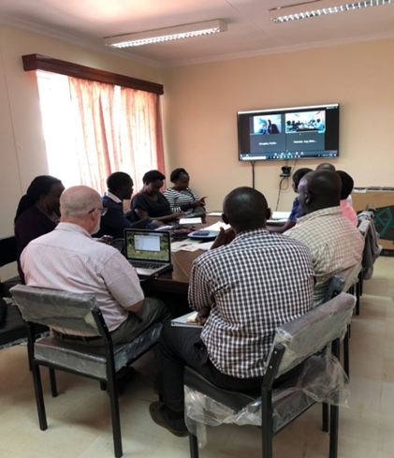
Video and Teleconferencing Facilities
The AMPATH Research Program facilitates communications for more than 80 conference calls per month for research collaborators in Kenya, Europe, and North America. These calls are supported by three teleconferencing suites hosted at the Chandaria Cancer and Chronic Disease Center on the Moi Teaching and Referral Hospital campus. The teleconferencing facility can accommodate up to 40 people. In addition to the teleconferencing facilities, the Research Program offers researchers a mobile Bluetooth speaker and a mobile phone for teleconferencing purpose. The AMPATH Program also hosts five videoconferencing suites that are available upon request for use by AMPATH researchers. The AMPATH Centre, situated on the grounds of Moi Teaching and Referral Hospital, hosts two of these facilities, while the remaining three facilities are hosted at the Chandaria Cancer and Chronic Disease Center. Each videoconferencing facility is furnished with a screen, audio system, internet services, furniture, and a laptop computer.
AMPATH Videoconferencing Facility

AMPATH Reference Laboratory
The AMPATH Reference Laboratory (ARL) was established in 2004 and is the primary laboratory used to support the AMPATH HIV care program and clinical trials and other research activities at AMPATH.
Physical space: ARL occupies approximately 8,000 square feet in the AMPATH Centre building on the Moi Teaching and Referral Hospital campus. It has eight dedicated labs: clinical biochemistry, hematology, molecular diagnostic, cytogenetics, flow cytometry, serology and biorepository. Access to the lab is controlled through a locked gated entrance with 24-hour security.
Staffing: ARL led by a Director (PhD-level) and supported by a Laboratory Manager (PhD-level) with a team of 21 highly skilled personnel who are Good Clinical Laboratory Practice and ISO 15189: 2012 trained and competent. Oversight of ARL is provided by an ARL Advisory Committee made up of Kenyan and non-Kenyan AMPATH faculty members with expertise in laboratory science and research.
Equipment: ARL has the following equipment: two microscopes – a florescent Lecia Microsystem and one light AO American; six -80 C degree Thermo Scientific freezers (one Jewett -40 C degree freezer and one -20 C degree freezer) for sample storage; six 2-8 degree refrigerators for reagent storage and management; two Brady barcode printers; five centrifuges (two Ependor microtube centrifugation and three Thermos Scientific temperature controlled centrifuges); two chemistry analyzers (COBAS Intergra 400 plus and a C111); two hematology analyzers (Beckman Coulter Ac•T 5diff AL); two Facscliburs for CD4/CD8 monitoring; Beckman Coulter Life Sciences CytoFLEX benchtop flow cytometer for leukemia/lymphoma diagnosis; M2000 RT thermocycler; M2000 sample preparation platform for molecular extraction and amplification; two four-module geneXpert equipment; one multiwash incubator; and one multiskan plate reader (capable of ELISA testing). The freezer temperatures are monitored on a 24-hour basis using the automated ELTEK temperature monitoring system. ARL has an operational Lab Information Management System and Type 111 water purification system. ARL performs sample shipment (including both serum samples and peripheral blood mononuclear cells) for protocols that require processing outside of Kenya (e.g. TB in Uganda, ACTG samples to BRI). These shipments include both serum samples and peripheral blood mononuclear cells. For ACTG studies, shipment is done using LDMS.
Available tests: Specific tests available at the lab include but are not limited to: CBC – performed using the Beckman Coulter ACT5 Diff analyzer. The lab processes 300-400 CBC requests daily; Blood Chemistries – primarily performed using the Roche’s Cobas 400 Integra Plus and the Hitachi 902 analyzers. The lab processes approximately 300-400 chemistry analytes daily; 4 Colour Flow cytometry – primarily performed using the BD FACS Calibur flow cytometer. The lab processes 300-400 requests for CD4/CD8 daily; Serological tests – primarily ELISA-based for HIV, HBV and HSV; Syphilis testing using the RPR and TPHA. The lab processes 10-100 requests for each of these tests daily; Molecular tests are all PCR-based and performed on the ABBOTT m2000 and Roche Cobas Amplicor platforms. Both HIV-1 RNA and DNA PCRs are performed. The lab processes 50-100 requests for either of these tests daily. ARL is in the process of building capabilities for HIV-1 resistance testing in collaboration with Brown University in the US. Currently all samples for HIV-1 resistance testing are processed for shipment to Brown University; TB culture, Identification and DST are performed on the Bactec MGIT 960 platform and LJ slants. The lab processes 10-30 requests for TB culture and identification daily. About 5 samples are processed for DST daily. ARL has 2 geneXpert machines. The AMPATH Mycobacteriology lab now runs protocols that cultures all microscopically TB smear-negative samples; all microscopically smear-negative but suspected TB cases; all fluids and tissues from suspected TB cases at autopsy for MTB identification; culture of all microscopically smear-positive samples for identification and drug susceptibility testing. Currently, ARL is leveraging support from ACTG to upgrade the mycobacteriology lab to a fully-fledged P3 facility. The lab is enrolled with CAP for TB; General microbiology-- culture and identification of common bacteria and fungi. The lab processes approximately 5 requests for bacterial and fungal culture daily. The lab is in the process of setting up Microbial AST capabilities; ARL has established full-fledged Histology and Immunochemistry labs.
Accreditation and quality control: ARL undergoes regularly scheduled inspections and meets U.S. laboratory accreditation standards. In 2012, ARL’s testing protocols were subjected to competency assessment by the Kenya Accreditation Services and awarded ISO 15189:2007 Accreditation. ARL was re-accredited for ISO-15189:2012 in February 2018 by the Kenya Accreditation Service (KENAS) through 2021. The lab participates in UKNEQAS, NHLS, API, RCPA, CAP external proficiency testing programs for all the tests performed. The lab has a rigorous internal quality assurance program. The lab is routinely audited by DAIDS-appointed audit firms. ARL has a number of SOPs in place to ensure the highest standards of quality and accuracy of testing facilities and procedures. ARL is enrolled in EQA programs for HIV RNA (VQA), CD4 assays (UK NEQAS and QASI), urine pregnancy (NHLS/WHO), hematology (API), and chemistry (API). The TB laboratory is designed to process TB smears including concentrated smears, culture, identification and drug resistance testing. ARL has been PPD certified since 2006. In addition, ARL was accredited for ISO 15189 quality management for medical laboratories by Kenya National Accreditation Services in 2010.
Biobanking: In 2018, the AMPATH Research Biorepository banked nearly 120,000 specimens for 25 active research studies. Most studies involve storage of samples for mass processing of lab testing at intervals or at the end of protocols (in sexual health, HIV/AIDS clinical trials, cardiovascular disease, malaria infection screening and pharmacokinetics). Biomaterials specimen processing and shipment continues in support of research in cardiovascular genomics, viral resistance, HIV/AIDS and cancer pharmacogenomics. The AMPATH Research Biorepository routinely ships specimens to large instrument facilities at IU, Duke, Brown and the NIH. The AMPATH Research Biorepository has a new centralized facility with expanded capacity in the Chandaria Cancer and Chronic Disease Center covering about 700 square feet. This new facility provides a central repository with space for eight -80 C degree freezers, liquid nitrogen storage, storage for paraffin and other specimens, and a dedicated laboratory space for specimen preparation and processing. This secure facility provides state-of-the-art computer tracking and storage system monitoring, climate control and stable power back-up.

Moi University Clinical Research Unit
Moi University Clinical Research Unit (MUCRU) was developed as part of the Indiana University AIDS Clinical Trials Group and has supported a total of 18 clinical trials to completion with three active trials. The unit supports AIDS Clinical Trials Group (ACTG), United Kingdom Medical Research Council and investigator-initiated research.
Physical space: MUCRU occupies 5,424 square feet on the third floor of the Chandaria building on the Moi Teaching and Referral Hospital campus and meets all ACTG physical and staffing requirements for an active clinical trials unit. The unit includes 15 rooms: four examination rooms, data room, nurse station/emergency room, phlebotomy room, recruitment /archiving room, clinical research site room, leader's office, coordinator's, regulatory affairs coordinator office, pharmacist of record's office, investigators' office and a pharmacy store equipped with wall mounted shelves, air conditioner, steel door, Eltek temperature monitoring system and two scientific refrigerators. A conference room is shared with other research projects at Chandaria and used for staff and CAB meetings and for site monitoring activities. MUCRU has three sinks along the corridors each with running water, a soap dispenser and hand dryer and washrooms for both staff and participants. Electrical power supply from the main grid is backed up by a generator. There is 24-hour armed security including bomb detectors. The facility has a vehicle for transportation of study samples to back-up labs as well as recruitment and retention activities.
Staffing: MUCRU is staffed by a site leader, deputy site leader, five investigators, four clinical officers, data manager, two assistant data managers, pharmacist, back–up pharmacist, pharmaceutical technologist, site coordinator, regulatory affairs coordinator, quality assurance/control manager, study nurse and three recruitment officers.
Community Advisory Board: MUCRU-Community Advisory Board (CAB) was established in 2004 as part of the ACTG. The CAB has six members who meet twice per month: one represents teachers, three represent patients (two adult and one youth), one represents a community-based organization focused on human rights, and one represents women’s issues. The group is charged with reviewing protocols utilizing standardized project-developed summary sheets and providing feedback early in the protocol development and initiation stage. The CAB is also responsible for community sensitization and dissemination of results to community stakeholders and serving as a conduit for community concerns about research activities and results.

Informatics Capacity
AMPATH was one of the first sites to pilot an electronic medical records system to better serve its patient population and provide clinicians with clinical decision support. AMRS provided the foundation for the development of OpenMRS, an open source medical records system developed by medical informatics experts and scientists from the Indiana University School of Medicine's Regenstrief Institute. OpenMRS is now the electronic record systems of choice in a number of African countries, including Kenya, and is active in over 70 countries worldwide.
Physical space: AMPATH’s Data Center is approximately 800 square feet and can accommodate 17 data personnel. The Data Center has grilled wide windows, and a metal door with a fixed deadlock. Access is restricted to authorized staff and requires one data staff member and one security officer. There is CCTV security cameras in use at the building. The room is attended by a staff member during normal working hours. There are 26 computers within the data centre which use the Ubuntu, a Linus Operating system and are guarded by Symantec Endpoint Antivirus. Back-ups are done automatically on a daily basis to the back-up disk. On a weekly basis, backup is done on a portable hard drive which is maintained off-site. The server room is approximately 300 sq. feet in size. It hosts 10 servers: one server is dedicated to Research, two are dedicated to data entry into the AMRS, and one is specifically used as a back-up of the others. The temperatures are kept at 18 degrees centigrade. The server room is secured with grilled windows and two doors, of which one is a steel door with deadlock. There is restricted access to the server room with only two keys, which are maintained by the IT administrators. The servers are also protected with a Symantec Endpoint Network Antivirus.
Staffing: When the data center was first established there were 26 data staff located in AMPATH’s central office and 16 data clerks at the peripheral sites to manage the manual entry of data into the AMRS system. The launch of the AMPATH point-of-care system in 2016 eliminated paper records in 26 of AMPATH’s major clinic sites. Staffing levels have been reduced to 13 AMPATH data staff with office space in the data center and three staff at peripheral sites as a result of this shift to direct data entry into the point-of-care system by clinic staff. The shift to point-of-care has also created opportunities to re-task data entry staff to additional monitoring and evaluation roles.
Services: AMRS is foundational for AMPATH, playing a vital role in research, clinical program monitoring and evaluation, reporting, delivery of clinical services, and clinical decision support. AMPATH has developed a cloud based medical records tool called Point-of-Care that is dramatically improving care for AMPATH patients. This system provides real-time data and reports for clinicians and is helping improve patient retention through improved decision support and immediate access to patient records through tablets and smartphones connected to cellular 3G Wi-Fi networks and powered through solar energy. AMPATH’s point-of-care system is deployed at AMPATH’s 26 largest clinic sites and has registered more than 220,000 patients with over a million patient encounters since its launch in 2016. This system has reduced patient wait times at clinics and improved access to patient records for caregivers.

Data Management and Analytic Capacity
AMPATH Data Analysis Team (ADAT) consists of a team of statisticians and data managers that collaborate with investigators throughout the AMPATH Research Program and Consortium, providing statistical and data management expertise, and facilitating construction of datasets from the AMPATH Medical Records System. ADAT team provides support for about 10 large-scale (e.g., NIH-funded R01s) research studies at any given time at AMPATH.
Physical space: ADAT has 3 offices for is biostatisticians, data analysts, and data managers: one office in the AMPATH Centre building and 2 offices on the research floor of the Chandaria Cancer and Chronic Diseases Center building on the Moi Teaching and Referral Hospital campus.
Staffing: ADAT is co-directed by a Moi University faculty and Brown University faculty in biostatistics and supported by a lead Scientific Programmer and Statistician, two staff-level biostatisticians, two data analysts, and three data managers, with additional support provided on a project-specific basis by additional faculty and staff at AMPATH Consortium institutions.
Equipment: Each ADAT staff are equipped with computers with access to updated versions of data management and statistical analysis software (e.g., SAS, STATA, NQuery, REDCap). The REDCap (Research Electronic Data Capture) server, dedicated for use by researchers at AMPATH, now supports research databases of over 80 ongoing projects. REDCap is supported with dedicated personnel from the AMPATH informatics team who are responsible for managing the server and user accounts. The server is maintained in the AMPATH Data Center (see Informatics section below).
Services: ADAT provides a range of critical data management and analysis services at all stages of proposal design, project implementation, and analysis of results and manuscript writing for investigators at AMPATH. Projects that require data management and analysis support consult with ADAT during AMPATH Research Program’s internal proposal review process, and investigators and ADAT co-directors identify the level of ADAT support that is required for their project. In general, required support for data management and biostatistics falls into one of three tiers: Consultation Only, Consultation Plus, and Full Scale Collaboration.
These activities include (but are not limited to): Contributing to grant proposals led by members of the AMPATH Consortium by providing input on design and analysis plans and generating preliminary analyses needed for the proposals; Providing statistical and data management support for research projects (e.g., recruitment of participants using AMRS, designing and maintaining electronic databases, data entry and data quality checks, and reporting to Data Safety and Monitoring Boards); Participating in preparation and review of scientific manuscripts (e.g., providing de-identified datasets, leading statistical analyses and contributing to methods and results sections of manuscripts); Generating and maintaining a ‘Master Dataset’ that converts raw data from AMRS to a research-grade database that is updated once or twice per year; and, Building data management and analysis capacity and infrastructure at Moi University in Kenya (e.g., through the Moi-Brown Partnership for Biostatistics Training).

AMPATH Qualitative Research Core (AQRC) was established in 2018 and provides critical support for investigators and research teams at AMPATH conducting qualitative research.
Physical space: AQRC office space and computers are housed on the second floor of the Chandaria Cancer and Chronic Disease Center building on the Moi Teaching and Referral Hospital campus.
Staffing: AQRC is led by a Moi University faculty member and consists of a full-time senior research assistant as well as temporary staff hired on contracts on an as-needed basis.
Equipment: AQRC staff have access to state-of-the-art qualitative research software (e.g., NVivo, Dedoose).
Services: Services provided by AQRC include (but are not limited to): consulting on the design and methods of qualitative research proposals, conducting qualitative interviews, focus group discussions, use of photovoice methodologies, transcription of qualitative data, translation, qualitative data management and analysis, and manuscript writing. AQRC also offers rigorous training services for research staff in qualitative methods.

Innovative Clinical Programs Providing Access to Unique Clinical Populations

HIV Care and Treatment Programs
AMPATH’s main clinic facility in Eldoret hosts three clinical modules dedicated to providing adult HIV clinical services and two clinical modules dedicated to pediatric and adolescent HIV clinical services. Each module contains four exam rooms and a procedure room in addition to triage and staffing rooms. The clinic sees approximately 250 people living with HIV per day. Four to five clinical officers (mid-level practitioners), five nurses, an outreach worker, a patient attendant, and at least one nutritionist staff the modules and each module has a supervising physician who consults for challenging cases. In addition, the AMPATH program supports HIV care and treatment in 811 clinics (testing sites, PMTCT sites, and ART clinics) throughout western Kenya averaging 1,500 new enrollments in HIV treatment per month. Peripheral clinics are permanent clinics that generally operate three to four days per week while satellite clinics are open one to four days per month and staffed by clinical personnel from an Eldoret clinic or one of the peripheral clinics. Travel times, by personal vehicle, between AMPATH clinic sites and the main AMPATH clinic in Eldoret range from 30 minutes to five hours. As of early 2021, there were approximately 170,000 patients on HIV treatment in the AMPATH program. AMPATH also operates a robust program to block mother-to-child transmission of HIV and has successfully reduced the rate of HIV transmission from mothers to their children to less than three percent.

Maternal, Newborn, and Child Health
With support from USAID, Saving Lives at Birth, Grand Challenges Canada, and the National Institutes of Health, AMPATH is spearheading novel approaches in maternal, neonatal, and child health across western Kenya. AMPATH has pioneered the development of community groups, called chamas, which are peer groups to support pregnant women and mothers led by community health volunteers as a platform for peer support, health education, and microfinance. Chamas are being scaled up throughout the population health catchment area over the next 3 years in four Counties across western Kenya. Currently there are over 3,000 women in the chamas program participating in 280 groups supported by over 500 community health volunteers.

Adolescent Health
Established in November 2016, the MTRH-Rafiki Center for Excellence in Adolescent Health is a combined adolescent medicine, adolescent HIV care and research clinic that provides a ‘one stop shop’ for free reproductive health, mental health, management of chronic diseases, HIV prevention and treatment services, and life skills for adolescents in Eldoret and the surrounding area. The clinic focuses on services for high-risk adolescents with a special emphasis on street-connected children and youth. The clinic includes a newly-renovated facility that provides care for nearly 1,000 adolescents in Eldoret. The clinic also serves as a training center for future OB/GYNS, pediatricians, nurses, social workers and counselors on providing adolescent-friendly care.

Non-Communicable Diseases
In 2009, AMPATH was designated as a Center of Excellence for Cardiovascular and Pulmonary Disease Research by the US National Heart, Lung, and Blood Institute. The AMPATH program is among the first in sub-Saharan Africa to layer programs targeting non-communicable diseases onto the infrastructure originally created for HIV care. Comprehensive Care Centers for HIV are transitioning to Chronic Disease Centers utilizing the same providers and infrastructure. Targeted conditions include hypertension, diabetes, chronic lung disease (predominantly due to indoor air pollution), cancer (predominantly cervical and breast) and mental health disorders. AMPATH has screened over 385,000 patients for chronic diseases such as diabetes, hypertension and mental illness and enrolled over 34,000 patients with diabetes, hypertension and mental illness in care at Chandaria Cancer and Chronic Disease Center, eight rural health centers and 27 rural dispensaries. AMPATH has also developed innovative, community-based solutions to ensure a consistent and secure supply of essential medicines with community groups and delivery.

Oncology
AMPATH’s Oncology Program was founded in 2008 to provide cancer treatment and build capacity for cancer care in Kenya. It has built a robust system of care in western Kenya and, in 2015, launched its main clinical care site in the Chandaria Cancer and Chronic Disease Centre. This facility provides state-of-the-art treatment and serves as a learning institute for Kenyan health professionals. The AMPATH Oncology Program has assisted the Kenyan Ministry of Health in drafting the Kenya National Cancer Control Strategy that outlines national health policies, addressed priority national health issues related to cancer, and plans for health professional training in oncology. The current focus of the AMPATH Oncology Program is cervical and breast cancer, hematology, pediatric cancer, telemedicine and education and training of oncology healthcare providers. More than 1,000 patients are seen and treated monthly, with over 45 physicians, nurses and physician assistants trained in oncology care and research, and more than 15 clinical sites provide established cancer treatment and care.

Population and Community Health
AMPATH's Population Health program collaborates with County Ministries of Health and the National Hospital Insurance Fund on the design, implementation, and evaluation of initiatives for universal health coverage and economic and social empowerment. Kenya’s strategy for universal health coverage relies on increasing enrollment through the national health insurer, the National Hospital Insurance Fund. AMPATH’s Population Health program has been piloting community empowerment and economic groups to support health insurance enrollment and integrated community and facility-based care models in four Counties in western Kenya. The approach is heavily based on primary and community models of care, and builds on AMPATH’s success in training and partnering with community health workers in HIV.

